Texas Middle School
Classroom Management System - Success Criteria and Examples

We firmly believe that when students have academic investment and a strong relationship with a teacher, they are more likely to be successful in their classroom behavior. However, we also value a structured classroom with clear expectations. As a school community, we believe every teacher should have a strong classroom management system focused on clear expectations, specific routines and structures, clear positive incentives, and specific teacher interventions to support student success.

Individual Classroom Management System: Success Criteria

Proactively planned routines | Teacher has proactively planned all routines and procedures for their class as a way to maximize learning time and minimize the chance for misbehavior due to misunderstanding or confusion.
Student ownership plans | Teacher has created a system for students to take ownership of classroom culture (e.g., class roles/jobs).
Positive incentives | Teacher has positive incentives unique to their classroom.
Reflection/calm space | Teacher has a space in the room where a student exhibiting behavior challenges can go to calm down, reflect, and self-regulate.
Tracking system | Teacher has a method for tracking positive behaviors as well as behaviors that need adjustment. This may take the form of a “point system.”
Chain of redirections & consequences | Teacher uses a consistent, logical chain of consequences so that students know what to expect each time their behavior does not meet expectations.
Accommodations | System includes accommodations for students with special needs or other populations so that ALL students can be successful in their classroom behavior.
Feedback | Teacher has a method to consistently gather feedback from students on classroom culture - what is going well and what can be improved

Highlighted = artifacts are attached

Deep Dive: Positive Incentives (Model)

As you read the positive incentive plan from Mr. J, ask yourself:
- How does Mr. J ensure that he intentionally builds a positive culture?
- How does Mr. J ensure that positive incentives go beyond positive rewards?
- What would you add or “make your own” from this plan?

Positive Incentive Plan: Mr. J’s Class

Bringing Joy
Celebrations and Chants | We will celebrate often, using chants that I will teach the class in the first few weeks of school: classroom chant; Table clap (boom boom clap); “Piece of cake” after finishing a problem; Balloon clap. Mr. J will also give whole class points for positive, joyful celebrations.
Funky Facts Friday | Mr. J will highlight a “funky fact” based on our current unit of study. Eventually, students will also present each Friday.
Music in Do First/Independent Work | Students earn music during Do First/independent time. Scientist of the month can make requests.
Hump Day Good News | Students and teacher share good news each Wednesday to help us “get through” the rest of the week.

Building Relationships
Lunch bunch | Students will have the chance to get lunch bunch in Mr. J’s classroom each Tues/Thurs. Lunch bunch on Tuesday will rotate between homerooms (all students can come unless in lunch detention) and Thursday will be a reward for exit ticket data/most improvement.
Ask Mr. J | On select Fridays, students will write down questions to “Ask Mr. J” and he will select some to answer
Monday questions | We will spend first 3-5 minutes after Do First each Monday talking about the weekend and giving life updates

Recognition
Scientist of the Month | Award given to scientist that shows growth, incredible tenacity, curiosity or integrity.
MVPs/MIPs | Posting and recognition of high scores and most growth from each class.
Phone calls home | Mr. J commits to at least 5 positive phone calls/texts home per week. Will shoot for 10!

Tangible Rewards
Tickets | On select days, especially before unit exams, Mr. J will give out tickets to have a raffle to pull from prize box.
Card home | Mr. J has “Star student” cards with a positive message about student that he gives out to take home to parent/guardian to show hard work.

Deep Dive: Student Ownership Plans (Model)

As you look at Ms. K’s class roles handout, think:
- How does Ms. K utilize jobs/roles to ensure student ownership of class culture?
- This is an example of “table roles.” What other class jobs/roles will you plan for?

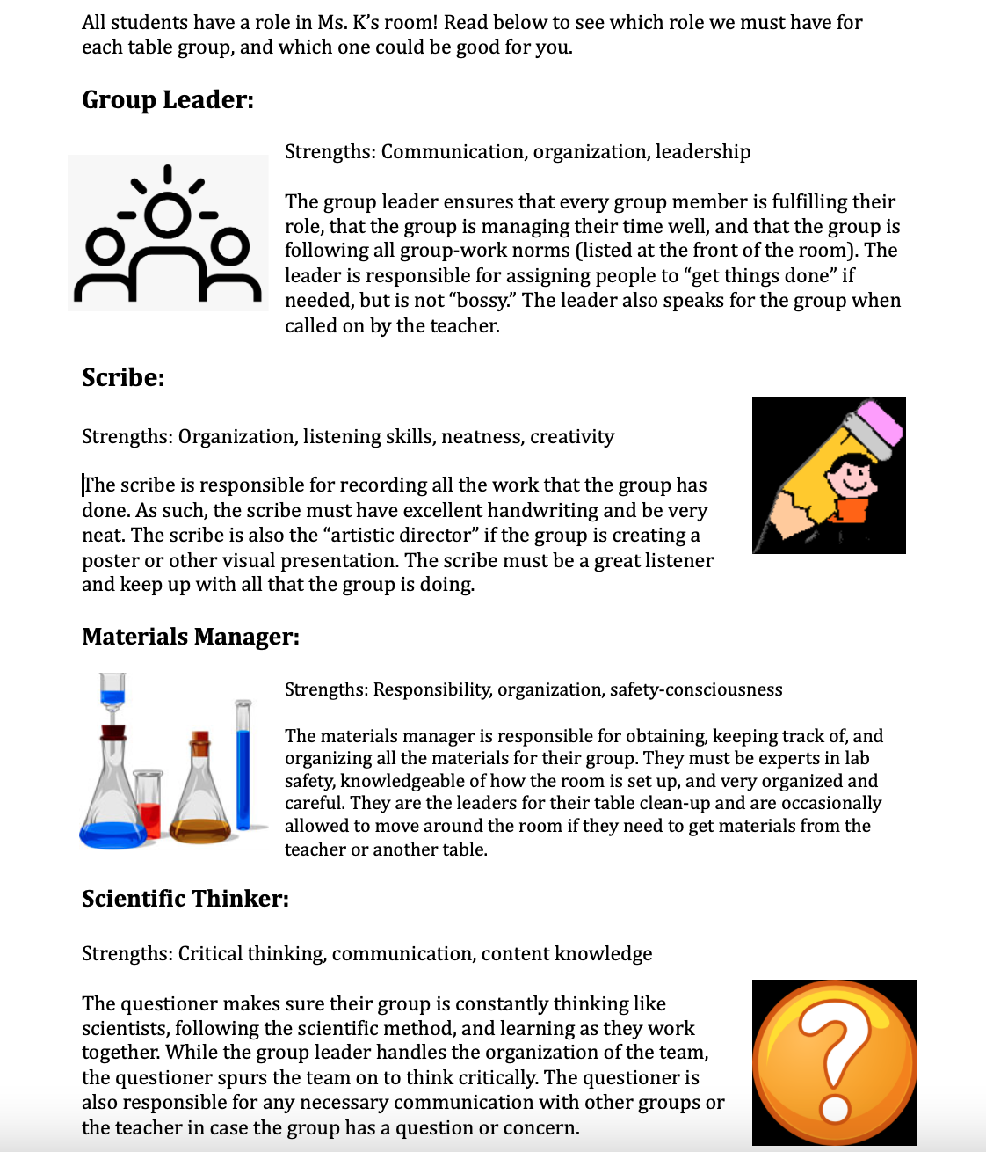

Deep Dive: Chain of Consequences (The Skillful Teacher)

The Skillful Teacher (Saphier/Hailey-Speca/Gower, 2008) provides a research-based approach to discipline and consequences. These range in order from small and least invasive to most invasive and serious. The steps in approaching misbehavior and delivering consequences are adapted from The Skillful Teacher and listed below. They can be seen as a ladder of increasing seriousness, in which generally you would try the first steps before moving up the ladder.

As you read, ask yourself:
- Which of these moves do I already do naturally?
- Which do I jump to too quickly? Which moves might I need to incorporate more of?
- Which moves should be a part of my communicated chain of consequences to students?

Least Invasive Redirections

1. Notice the Behavior and Give a Look, Use Proximity, or Publicly Narrate Expectation
2. Excuse Yourself (stop what you were doing or work with student) and Square Off
- Terminate whatever you’re doing.
- Turn completely.
- Face the student squarely and look the student in the eye.
- Make your face expressionless, arms hanging comfortably.
- Take two relaxing breaths.
- The student may fold, but if not...
3. Name.
- Say the child’s first name only, in a bland tone.
- Take two more relaxing breaths.
- The student may fold, but if not…
4. Move in (say nothing)
- Walk slowly to the edge of the student's desk until your legs touch it.
- Stand upright.
- Take two relaxing breaths.
- The student probably folds, in which case, you…
- Thank the student, genuinely and warmly.
- Wait a few seconds more.
- Go to the second student who was involved (if relevant).
- Thank him or her.
- Return slowly to the student you were previously working with.
- Wait for two relaxing breaths.
- Resume instruction.
- But if the student didn’t fold…
5. Prompt
- Lean over at the waist, resting your weight on one palm (you’re back at the student’s desk).
  - Deliver a prompt on exactly what you want him or her to do next (“Carrie, you have two more problems to do. Let’s finish them up”).
  - If the student starts working, wait for two more relaxing breaths.
  - Then do the “thank and move out” sequence.
  - But in the unlikely event student still doesn’t fold…
  - Palms (say nothing).
  - Lean slowly across the child’s desk, and place both palms flat on the far side of the desk from you.
  - Look at the student for tow relaxing breaths.
  - When he or she resumes work, wait two more relaxing breaths.
  - Then do the moving out.
- Backtalk
  - If the child displays helplessness, denial, blaming, tangents, or accusing you of incompetence, give them a neural look (“withering boredom”), say nothing and take two relaxing breaths.
  - But if there’s more backtalk…
- Elbow and prompt.
  - Bend your elbow and place it on the child’s desk.
  - Repeat the prompt.

Small Consequences

6. Acknowledge a Change in Behavior and Offer Help.
- “Juan, I notice you’ve had a hard time staying focused today. Is there something I can do to help you get back on track?”

7. Quiet Time.
- “Sara, I think you need a little quiet time to regain focus. What part of the room would be good for you to use.

8. Warning.
- “That’s 1, Marcus.”
- For a warning to be effective, there should be an established system in your classroom where students are aware that a warning or warnings lead naturally to a consequence.

9. Re-education
- Removing student from another time of day (lunch, activity time) to reteach and reflect.

10. Counting or Anecdotal Record Keeping
- Speak with the student after class - give them a count of how many times they did the undesirable behavior. Make a plan for reducing the behavior and a signal for how you will count it.
- Could be done in tandem with collaborative problem solving.

11. Pull the Card
- This is a tangible form of a warning, with an example being pulling a card with the student’s name on it from a file, placing it on their desk, and making eye contact with the student with a neutral expression.

12. Letter/Phone Call Home

Medium to Large Consequences

13. Student Completes a Behavior Reflection in Writing
14. Time Out in the Classroom (Reflection Desk)
15. Time Out in another Classroom (Reflection Room)
16. Phone Call Home in the Moment with Student
17. Parent Conference with Home Reporting and Consequences
18. In-School Suspension***
19. Saturday School***
20. Parent Shadow in School***
21. Send Student Home***
22. Out-of-School Suspension***
23. Expulsion***

*** All of these consequences require approval of administrators and administrator discipline support.
Deep Dive: Feedback (Model)

As you look at how Ms. L gets feedback from her students, ask yourself:
- How does this survey contribute to classroom culture?
- How do you think Ms. L aligns her questions to her vision for classroom culture?
- What questions would match your vision for your own classroom culture, and which would you add or edit?

Ms. L’s Student Survey – October

To close out this quarter, please take this survey! Answer honestly so I know what is going well and how we can get better together.

 | Strongly Disagree | Disagree | Neither/Unsure | Agree | Strongly Agree
Ms. L cares about me as a person.
Students in the class are respectful towards Ms. L.
Students in the class are respectful towards me.
I feel like I am able to follow the rules well in this class.
Ms. L treats me fairly.
When she teaches, Ms. L moves too quickly for me.
When she teaches, Ms. L moves too slowly for me.
When someone in the class does not follow the rules, Ms. L responds well and helps solve the problem.
I trust Ms. L.
I look forward to this class.
I try my best in this class.
What changes would you make to this class?

What are some specific things Ms. L can do to make this class better

